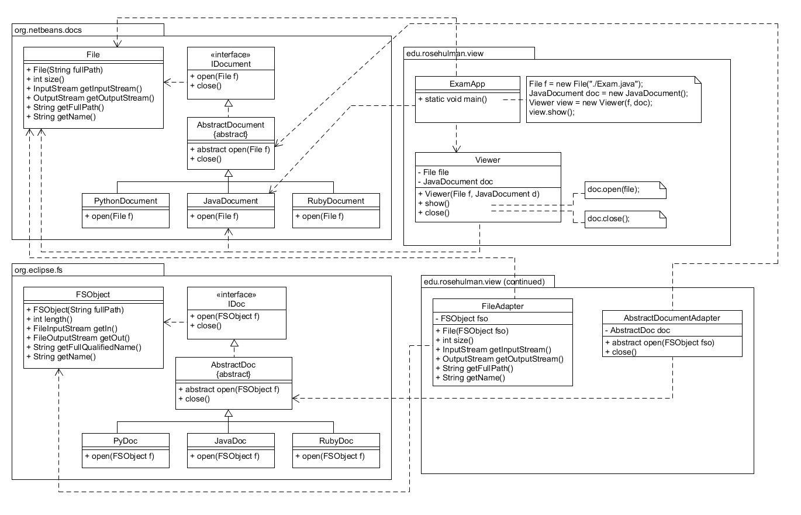

The FileAdapter extends File and implements all of its methods by invoking FSObject’s methods. The File is constructed by passing the path of the FSObject to the File constructor. The AbstractDocumentAdapter converts between AbstractDocs and AbstractDocuments.